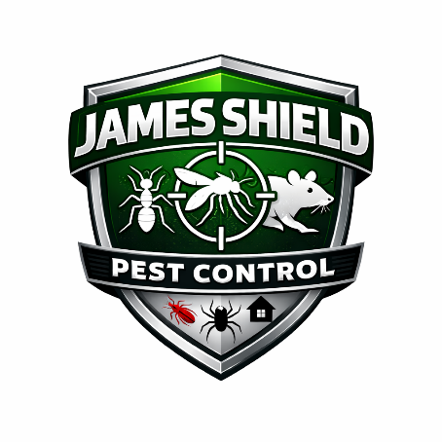
James Shield Pest Control
Employee Benefits Policy

1. Purpose
James Shield Pest Control provides employee benefit programs designed to protect employees and their families from financial loss resulting from medical, dental, and vision expenses. These benefits are intended to support employee health, financial stability, and overall well-being.
This policy outlines eligibility, enrollment procedures, and general benefit provisions.

2. Eligibility
Full-time employees (40 hours per week) are eligible to participate in Company-sponsored benefit programs.
Health, dental, and vision coverage becomes available on the first day of the month following completion of the 180-day introductory period, provided enrollment forms are submitted timely.
Part-time, temporary, and contract employees are not eligible for benefits unless required by applicable law.

3. Enrollment
Eligible employees must complete enrollment forms during:
- Initial eligibility period
- Annual open enrollment
- Qualified life events (marriage, birth, loss of coverage, etc.)
Failure to enroll within the designated enrollment window may result in delayed coverage until the next open enrollment period unless a qualifying life event occurs.

4. Summary of Benefits
The Company currently offers the following benefit plans:
- Health Insurance
- Dental Insurance
- Vision Insurance
This policy provides a summary of benefits that may be offered at the Company’s discretion. Actual coverage, limitations, exclusions, and terms are governed by the official plan documents and Summary Plan Descriptions (SPDs).
In the event of a conflict between this policy and the plan documents, the plan documents control.

5. Employer Contributions
James Shield Pest Control contributes toward the cost of employee premiums. Employees are responsible for the remaining premium portion through payroll deductions.
Premium rates may change annually.

6. Plan Administration
All benefit programs are administered according to the terms of the applicable insurance contracts and ERISA (where applicable).
The Company reserves the right to amend, interpret, modify, or terminate any employee benefit program at any time without prior notice to the extent permitted by law.
For complete plan documents, contact your supervisor or Human Resources.

7. Continuation of Coverage (COBRA)
Employees and covered dependents may be eligible to continue health coverage under COBRA following certain qualifying events, as required by law.

James Shield Pest Control Benefit Plans

1. Health Insurance Plan
Provider: Pioneer Valley Health Insurance Group
Plan Name: ShieldCare Preferred PPO
Plan Type
Preferred Provider Organization (PPO)
Monthly Premium (Employee Portion)
Coverage Type | Total Premium | Company Pays | Employee Pays
Employee Only | $650 | $450 | $200
Employee + Spouse | $1,350 | $800 | $550
Employee + Child(ren) | $1,200 | $750 | $450
Family | $1,800 | $1,000 | $800

Deductible
- $1,500 Individual
- $3,000 Family

Out-of-Pocket Maximum
- $5,000 Individual
- $10,000 Family

Co-Pays
- Primary Care Visit: $30
- Specialist Visit: $50
- Urgent Care: $75
- Emergency Room: $300

Coinsurance
- 80% covered in-network (after deductible)
- 60% covered out-of-network

Prescription Coverage
- Tier 1 (Generic): $15
- Tier 2 (Preferred Brand): $35
- Tier 3 (Non-Preferred Brand): $75
- Specialty Drugs: 30% coinsurance

Additional Benefits
- Preventive care covered at 100% in-network
- Telehealth services included
- Mental health coverage
- Maternity coverage
- Wellness program incentives

2. Dental Insurance Plan
Provider: HarborStone Dental Assurance (Fictional)
Plan Name: HarborStone Standard Dental Plan
Monthly Premium (Employee Portion)
Coverage Type | Total Premium | Company Pays | Employee Pays
Employee Only | $45 | $30 | $15
Family | $120 | $70 | $50

Deductible
- $50 Individual
- $150 Family

Annual Maximum Benefit
- $1,500 per covered person

Coverage Levels
- Preventive Care (cleanings, exams): 100% covered
- Basic Procedures (fillings): 80% covered
- Major Procedures (crowns, root canals): 50% covered
- Orthodontia (children only): 50% covered (lifetime max $1,000)

3. Vision Insurance Plan
Provider: ClearSight Vision Administrators
Plan Name: ClearSight Advantage Vision
Monthly Premium (Employee Portion)
Coverage Type | Total Premium | Company Pays | Employee Pays
Employee Only | $20 | $12 | $8
Family | $55 | $30 | $25

Coverage
- Annual Eye Exam: $10 copay
- Frames: $150 allowance every 12 months
- Lenses (standard): Covered in full
- Contact Lenses: $130 allowance

Frequency
- Eye exam: once every 12 months
- Frames: once every 24 months
- Lenses: once every 12 months

Additional Optional Benefits
James Shield Pest Control may also offer:
- 401(k) Retirement Plan with 4% Company Match
- Life Insurance (2x Annual Salary)
- Short-Term Disability
- Long-Term Disability
- Employee Assistance Program (EAP)

